**T2** 2023

Coverity Scan Static Analysis Report

Hardhard Enterprises

Statement of Intent

Overview

This document aims to provide a record of static code analysis performed on a specific issue from the Coverity SAST scan for the NASA ION Open-Source code 4.1.1 project.

The primary purpose of this document is to validate the issue identified via the automated detection process to eliminate false positives.

Depending on findings, secondary purposes can include but are not limited to listing/providing recommended fixes alongside a list of attack vectors and potential exploits for consideration.

Reporting Best Practices

Please ensure best practices are kept when completing the document via regularly updating the Acronyms and Abbreviations table alongside any iterations made to the Document History table. This will allow other members to identify any updates and progress made across trimesters easily.

When using code snippets, please use screenshots that are clear and easy to read, alternatively, use words built-in code formatter found [here](https://appsource.microsoft.com/en-us/product/office/WA104382008?tab=Overview).

Document Naming Conventions

Naming conventions for this file are as follow; SAR_{CID}. For example, when investigating issue 123456 the file name would be SAR_123456.docx

Document History

|  |  |  |  |
| --- | --- | --- | --- |
| **Dates** | **Version** | **Author** | **Comments** |
| 4/9/2023 | V0.1 | Chong Zhang | Initial document |
|  |  |  |  |
|  |  |  |  |

Table of Content

Contents

Introduction 3

Objective 3

Scope 3

Acronyms and Abbreviations 3

Code Review and Analysis 4

Outcomes 4

Observations 4

Supporting Evidence 4

Conclusions and Recommendations 4

References 5

Appendix 6

# Introduction

## Objective

The primary objective of this analysis is to determine whether the defects identified in the Coverity Report for the ION Open Source 4.1.1 project are:

* Indeed, defects.
* Potentially exploitable.

The secondary objective of this analysis, where applicable, is to provide the following:

* Recommendation(s) to fix.
* Any exploit for consideration.

## Scope

This static code analysis is limited to the ***Improper use of negative value*** type defect identified in the following CIDs: ***1520816***

# Acronyms and Abbreviations

Please keep an updated list of acronyms and abbreviations used throughout the report.

|  |  |
| --- | --- |
| **Acronym** | **Meaning** |
| DTN | Delay/Disruption Tolerant Network |
| ION | Interplanetary Overlay Network |
| CID | Coverity Issue Identification Number |
| CWE | Common Weakness Enumeration |

# Code Review and Analysis

## Overview

Coverity identifies **CID-1520816 Improper use of negative value** as a Medium impact, and the category is integer handing issues. It appears in **rfx_insert_contact**: Negative value can be returned from function is not being checked before being used improperly (CWE-394). This means the negative value may be unexpected by later operations, causing incorrect computations.

## Observations

The issue can be found in the rfx_insert_contact function in the /ici/library/rfx.c file. Within this function, negative value can be returned from function is not being checked before being used improperly. In this case, regionIdx is assigned a negative value. It is used as an index, but the index cannot be negative.

The problem starts on line 1154 in /ici/library/ion.c, where the function ionPickRegion(regionNbr) returns a negative value. On line 1725 of rfx.c, assign regionIdx = ionPickRegion(regionNbr). The function insertContact() takes the regionIdx as an argument on line 1726 and uses it as an index on line 820.

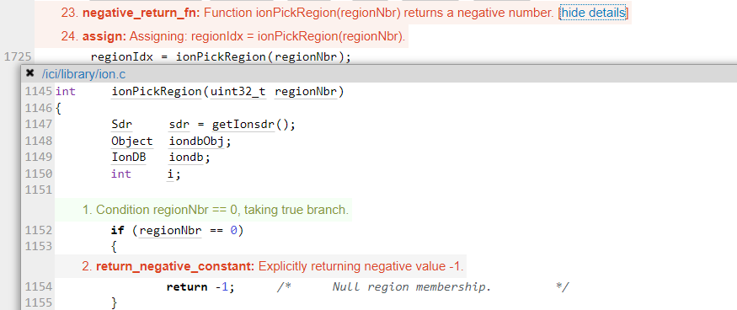

Fig. 1. Coverity Static analysis results

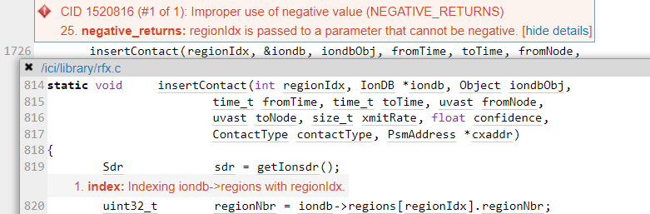

Fig. 2. Coverity Static analysis results

## Supporting Evidence

Please provide any supporting evidence, and feel free to make references to documents in the appendix.

# Conclusions and Recommendations

This is a bug of the code. The function returns a negative value, which is used as an index, and the program won't work properly.

This bug doesn't need fixing. Before this bug appeared, the function was already failing. In theory, this bug won't show up.

References  
Common Weakness Enumeration (n.d.) CWE-394: Unexpected Status Code or Return Value, <https://cwe.mitre.org/data/definitions/394.html>

Appendix

Include additional information/documentation here to help the readers understand complex information.